INFORMATION SYSTEMS: ICE TASK 2
Group 7: Thamsanqa Nkosi Ncube - ST10482062 Kandyce Smit – ST10467645

Lecturer: Moses Olaifa
Module: INSY6211

Table of Contents
Scenario 1 – Done by Thamsanqa Nkosi Ncube (ST10482062) 2
User Stories 2
Acceptance Criteria 2
Events 2
Use Cases and Actors 3
Use Case Diagram 4
Scenario 2 – Done by Kandyce Smit (ST10467645) 5
User Stories: 5
Acceptance Criteria: 5
Events 6
Use Cases and Actors 6
Use Case Diagram 6

Scenario 1 – Done by Thamsanqa Nkosi Ncube (ST10482062)

User Stories
User Story 1: As someone who is a healthcare provider, I want to quickly search and retrieve a patient’s digital record so that I can make informed clinical decisions without any delays
User Story 2: As a medical staff member, I want to patient information in a structured digital form so that information is accurate and standardized

Acceptance Criteria
- User Story 1:
  - The user can search for a patient using their unique ID, name or phone number
  - The system must return a complete patient record in under 3 seconds
  - The user can view most recent entry at the top of the record

- User Story 2:
  - The user can view available time slots for each doctor
  - The system prevents double booking
  - The user must mark a patient as “checked-in” upon arrival

Events
External: Patient physically arrives at the hospital
Temporal: Whenever the month ends and the 1st of the new month begins
State: A patient has not visited the hospital in over 6 months and the record becomes outdated
External: Patient calls or visits the hospital to schedule and appointment, resulting in the receptionist booking a slot.

Use Cases and Actors
- Use Case 1:
  - Use Case: Search Patient Record
  - Actor: Healthcare Provider

- Use Case 2:
  - Use Case: Check in patient
  - Actor: Receptionist

- Use Case 3:
  - Use Case: Manage User Access
  - Actor: System Admin

- Use Case 4:
  - Use Case: Receive Notification
  - Actor: Patient

- Use Case 5:
  - Use Case: Update Medical Record
  - Actor: Healthcare Provider

Use Case Diagram
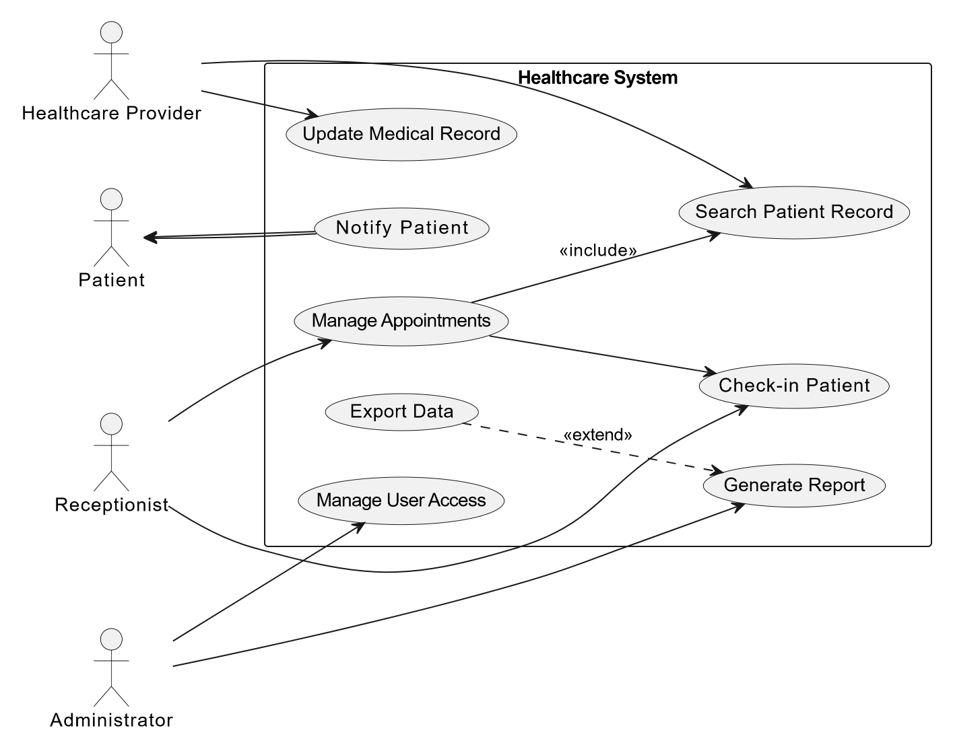

Scenario 2 – Done by Kandyce Smit (ST10467645)

User Stories:

User Story 1: as a city planner, I want to be able to manage traffic flow so that the overall management of traffic across the city will improve and congestion can be reduced.
User Story 2: As a Driver, I want to receive real-time traffic updates so i can choose the fastest route and avoid congested areas.

Acceptance Criteria:
User Story 1 – City Planner:
Acceptance criteria 1:
- Given - I am a city planner logged into the traffic management system
- When - I access the traffic management dashboard.
- Then - The system must display a live overview of traffic conditions across the entire city, and allow me to view, adjust, and monitor traffic flow at any intersection.
Acceptance criteria 2:
- Given - I am a city planner monitoring a specific area of the city
- When - I identify a congested area on the dashboard
- Then - The system must allow me to intervene by adjusting traffic signal timings or redirecting traffic flow in that area to reduce congestion

User Story 2 – Driver:
Acceptance criteria 1:
- Given - I am a driver using the traffic management app or GPS system
- When - traffic conditions change on or near my current route
- Then - The system must immediately send me a real-time update showing the affected area and suggest the fastest available alternative route
Acceptance criteria 2:
- Given - I am a driver planning a journey before leaving
- When - I enter my destination into the system
- Then - The system must display the current traffic conditions along my route and recommend the fastest route based on live data

Events

External Event - Driver requests real-time traffic update
Temporal Event - The system automatically generates a daily traffic summary report at midnight
State Event - AI system detects an accident and sends notification

Use Cases and Actors

- Use Case 1: Request real-time traffic update
Actor for Use Case 1: Driver
- Use Case 2: Manage traffic flow
Actor for Use Case 2: City Planner
- Use Case 3: Dynamically adjust traffic signals
Actor for Use Case 3: Automated System
- Use Case 4: Detect incident and send alert
Actor for Use Case 4: Automated System
- Use Case 5: Monitor city-wide traffic dashboard
Actor for Use Case 5: City Planner

Use Case Diagram

